**SALEAE LOGIC ANALZER**

It I hardware toll for digital signal analysis and debugging. It is designed to capture and analyze digital signals in electronic circuits

**FEATURES:**

**1.Digital signal analysis**: it captures and analyze digital signals .it can be used to visualize and debug digital communication protocols such as I2C, SPI, UART, CAN and more

**2.Multiple channels**: 4to16 channels. Each channel can be used to monitor a separate digital signal.

**3.High sampling rates**: supports high sampling rates, allowing it to capture fast changing digital signals accurately.

**4.software interface**: it is accompanied by saleae logic software.it allows users to view the captured data in different formats such as waveform, data table and protocol decoder

**5.protocol decoding**: it supports built-in protocol decoders for various communication protocols. This software can decode and display information about the communication on the bus

**6.Triggering and filtering**: users can set up triggers to capture specific events or condition in the digital signal.

**7.cross-platform compatibility**: available for windows, macOS, Linux

**8.Integration with other tools**

**9.analog input**: it also offers analog input channels allow users to capture both digital and analog signals

**Software interface**

1.device connection: device connected to computer via USB

2.channel configuration: you can enable or disable channels based on your requirements

3.waveform display

4.time ruler

5.data table: it provides a detailed breakdown of the digital data.it may show binary, hex, or ASCII representations of captured signals

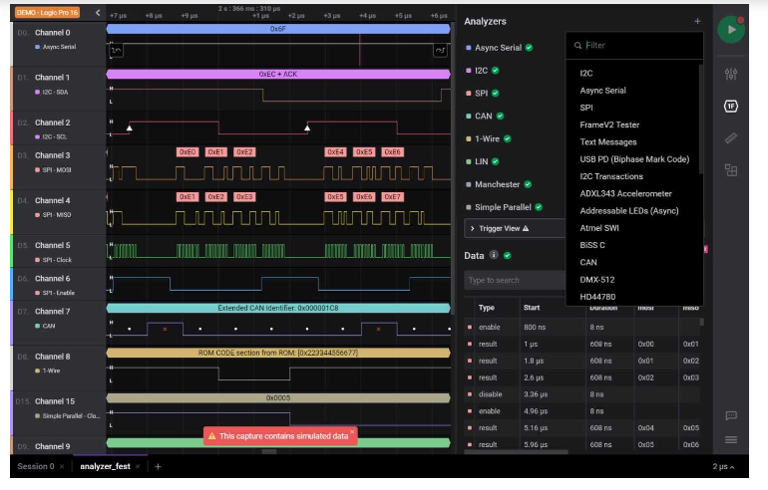

6.Protocol decoding

7.Zoom and pan controls

8.Trigger configuration

9.Toolbar

10.Settings and configuration: to customize parameters such as sampling rate, trigger conditions and more

11.Export options: it exports like CSV and MATLAB scripting